New Dis-Eur-Czech Republic-Moravia-Dolní Věstonice-Figurine-Mammoth-nearly Abstract-26,000 BP

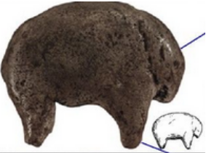

**Formal Label:** Czech Republic-Moravia-Dolní Věstonice-Figurine-Mammoth-26,000 BP

Display Description: This nearly abstract figurine of a mammoth

**Accession Number:**

**LC Classification:** GN772.22.C95

**Date or Time Horizon:** 26,000 BP C14

**Geographical Area:** Moravia in the Czech Republic, at the base of Děvín Mountain

**Map, GPS Coodinates**: 48.88822 16.64369, 40° 26' 46" N 79° 58' 56" W

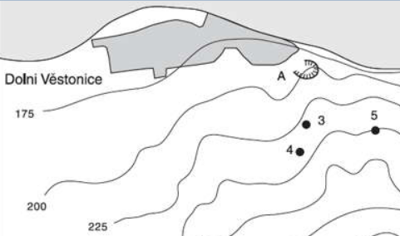 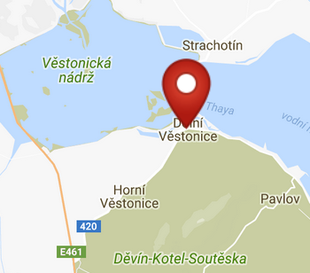 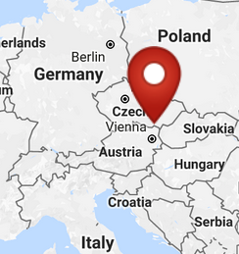

Fig. 2. Map of the location of Dolní Věstonice sites. Key: 3. Dolní Věstonice II; 4. Dolní Věstonice II-A; 5. Dolní Věstonice III; A. Dolní Věstonice source of stone. From Verpoorte 2000.

Figs. 3-4. Maps of the location of Dolní Věstonice from http://latitude.to/img/latitude-logo.svg.

**Cultural Affiliation:** Gravettian period (27,000-20,000 BP)

**Medium:** burnt clay.

**Dimensions:   
Weight:**

**Provenance: Naturhistorische Museum in Vienna.**

**Condition: museum replica in resin.**

**Discussion:** Dolní Věstonice, Moravia in the Czech Republic, is at the base of Děvín Mountain, 549 m (1,801 ft), and dates to the Gravettian period (27,000-20,000 BP). This nearly abstract carving of a mammoth provides a glimpse into the initial development of an aesthetic sense of geometric volumes that approach the animal as an artistic entity and not as a rationalistic entity that could be identified by its biology.

**References:**

Trinkaus, Erik and Jiri Svoboda (Eds.) 2005.*Early Modern Human Evolution in Central Europe: The People of Dolní Vestonice and Pavlov* (Human Evolution Series). New York: Oxford University Press.

